Lecture/ E-learning notes

Course number: **17CE3205**

Course name: **Quantity Surveying & Valuation**

Class: III B. Tech

Branch: Civil Engineering



Department of Civil Engineering

**N.B.K.R INSTITUTE OF SCIENCE AND TECHNOLOGY**

**(AUTONOMOUS)**

AFFILIATED TO JNTU, ANANTAPUR

VIDYANAGAR, SPSR NELLORE, ANDHRA PRADESH

**ESTIMATING AND COST ENGINEERING**

**UNIT - I**

**INTRODUCTION**

“What is the purpose and necessity of studying this subject?” This is the first question which arises in mind. The answer lies in the following questions:-

1. Has one got enough money to spend on the construction ?
2. Has one got ample time that one can wait for the completion of the construction ?
3. Has one got resources that one can arrange any amount of desired

material to be used in construction ?

If the answer is *YES*, then the study of this subject is useless. But if the answer is

*NO*, then the question arises, “which are the factors necessitating the study of thissubject.” Any person indulged in the Civil Engineering profession can clearly think of these factors i.e. set amount of funds, costly labour ( skilled and unskilled), difficulty in getting good building materials, particularly cement and day to day rising cost of steel, bricks, timber etc. Also *economy* and *standard* of the construction are two important things required. Standard of construction can be achieved by careful supervision and selecting proper specifications whereas for Economy, planning is a must. The total quantity of various materials used in construction, if known before hand, can help the planning towards economy.

**TYPES OF ESTIMATES**

The estimates may be divided in to the following catagories:-

1. Preliminary or Approximate estimate.
2. Rough cost estimate based on plinth area.
3. Rough cost estimate based on cubic contents.
4. Detailed estimate.
5. Annual repair estimate.
6. Special repair estimate.
7. Revised estimate
8. Supplementary estimate.
9. **Preliminary or Approximate estimate**

This estimate is prepared to decide *financial aspect*, *policy* and to give idea of the

cost of the proposal to the competent sanctioning authority. It should clearly show the necessity of the proposal and how the cost has been arrived at

The calculations for approximate estimate can be done with the following data. The data can be had from a similar construction already complete in the nearby area, excuted by the department.

For example: To calculate approximate estimate for a Hospital, per bed cost is calculated from the recent campleted hospital and is multiplied with the number of beds required. Similarly for a house, per square metre plinth area is calculated and is multiplied with the proposed covered area. The specifications should also be same. For a road, expenditure of per kilometer length is taken, width also plays the role.

The following documents should be attached with it.

1. Detailed report
2. Site plan of the proposal
3. It should also clearly mention about the acquisition of land, Provision of electric and water supply etc.
4. **Plinth area Estimate (Based on Rough Cost)**

Plinth area of a building means Length x Breadth ( roofed portion only )

excluding plinth offsets. The estimates are prepared on the basis of plinth areas of the various buildings proposed to be constructed. The **rates** are being arrived at the dividing the total cost of construction with its plinth area. For example if total cost of a building is Rs. 2 lac and its plinth area is 50 sq. m. then plinth area rate =2,00,000 = Rs.4000/- per

50

sq.m. Using this rate as basis of the next construction, approximate or rough cost of the proposal can be arrived at by multiplying the plinth area of the proposed building with this plinth area rate.

The following documents are attached with the estimate.

1. Line plan with brief specifications.
2. Cost of various services added i.e. electric and water supply etc.
3. North line should be shown clearly on line plan.
4. **Cubic Contents Estimate (Based on Rough Cost)**

The cubic contents of a building means plinth area x height of the building. The

height is taken from top of floor level to top of roof.

The cubic contents of the proposed building are multiplied with cubic rates arrived at for the similar construction i.e. total cost of construction divided by cubic contents = cost per cubic metre.

Documents attached are as in No. 2

(Administrative approval is granted on rough cost estimate)

1. **Detailed Estimate**

After getting Administrative approval on rough cost estimate, detailed estimates

are prepared.

In this, the estimate is divided in to sub-heads and quantities of various items are calculated individually.

In the end of the detailed quantities, an *abstract* of *cost* giving quantities of each item and rate of every item according to the sanctioned schedule of rates shall be attached. In case of non-schedule rates i.e. rates which are not given in the sanctioned schedule of rates, proper analysis of rates shall be attached. If however the work proposed to be constructed is located in a remote place, the provision for the carriage of the material shall be added in the estimate to avoid any excess over the administratively approved estimate later on. Detailed specifications & report should also be attached with the estimate. Technical sanction is given on detailed estimate.

The detailed estimate shall also provide for the cost of approach road, water supply,

electric installations and acquisition of land etc, so as to call it a comprehensive estimate.

5. Annual repair estimate

In order to keep building and roads in perfect condition, annual repairs should be carried

out as follow:-

1. In case of a building-white washing, oiling and painting of doors and windows, cement plaster repairs (inside & outside), repairs of floors etc. In no case this annual repair amount should increase more that 11/2% to 2% of the capital cost of the building.
2. In case of a road-filling patches, maintenance of berms etc.

6. Special repair estimate

If the work cannot be carried out of the annual repair funds due to certain reasons resulting in the genuine increase in cost, then special repairs estimate is to be prepard. The reason of increase may be:-

1. In case of a building-opening of new doors, change of floors, replastering walls etc.
2. In case of roads-if the whole surface is full of corrugation & patches, then the total surface is to be scarified. The old metal is taken out, consolidation by adding more metal is done and top surface is repainted.

7. Revised estimate

When the sanctioned estimate exceeds by 5% either due to the rate being found insufficient or due to some other reasons, a fresh estimate is prepared which is called a Revised Estimate. A comparative statement on the last page of the estimate is attached giving there in the reasons of the increase of cost in case of each item.

8. Supplementary Estimate

This is fresh detailed estimate in addition to the original sanctioned estimate paepared when additional works are deemed necessary during the progress of a work to supplement the original works. The abstact of cost should show the amount of the original sanctioned estimate as well as the supplementary amount of the original sanctioned estimate as well as the supplementary amount for which sanction is required.

**METHODS OF TAKING OUT ESTIMATES**

The calculations of quantities of materials can be done using various methods of estimates. The application of an individual method depends upon the design and shape of the building. The different methods are as under:

1. Centre line method.
2. Crossing method.
3. Out to out and in to in method.
4. Bay method.
5. Service unit method.

1. Centre line method

This method is suitable only if the offsets are symmetrical and the building is more or less rectangular in shape. The centre line of the building is determined carefully after doing deductions for repeated measurements (as explained in the next problem). This centre line acts as length for the complete calculations of the estimate. If the deduction is not cared for the results of estimates may be wrong. All the walls should have the same section.

2. Crossing Method(LONG WALL and SHORT WALL METHOD)

In this method, lengths and breadths of the masonry walls at plinth level are taken (internal dimension of the room + thickness of the walls) for calculating quantities. The symmetrical offsets are a must as in the case of centerline method. 3. Out to out & in to in Method

This method is most practicable under all circumstances and is generally followed in the P.W.D. for computing the quantities of various items. The estimation in this book has been done using this method.

4. Bay Method

This method is useful and is generally followed in case of building having several bays. The cost of the one class room is worked out and then multiplied by the number of bays in that building. The extra cost of the end walls and difference in framing. If there is any, should be made, so as to arrive at the correct cost.

5. Service Unit Method.

This method is followed in cases such as school building where there are so many class rooms. The cost of one class room us worked out and then multiplied by the number of class rooms to be constrused. In case of Hospitals, the service unit is a bed, in case of Water Tank, it is a litre and in case of Cinema Hall, the service unit is a seat.

**PROBLEM: I**

Calculate the quantities of the following items from the given figure, 3.12 upto G.L., using

(a) **Centre line method:**

**(b) Crossing method:**

* 1. Excavation for foundations.
  2. Cement Concrete in foundations.
  3. Brick work in cement mortar (1:4)

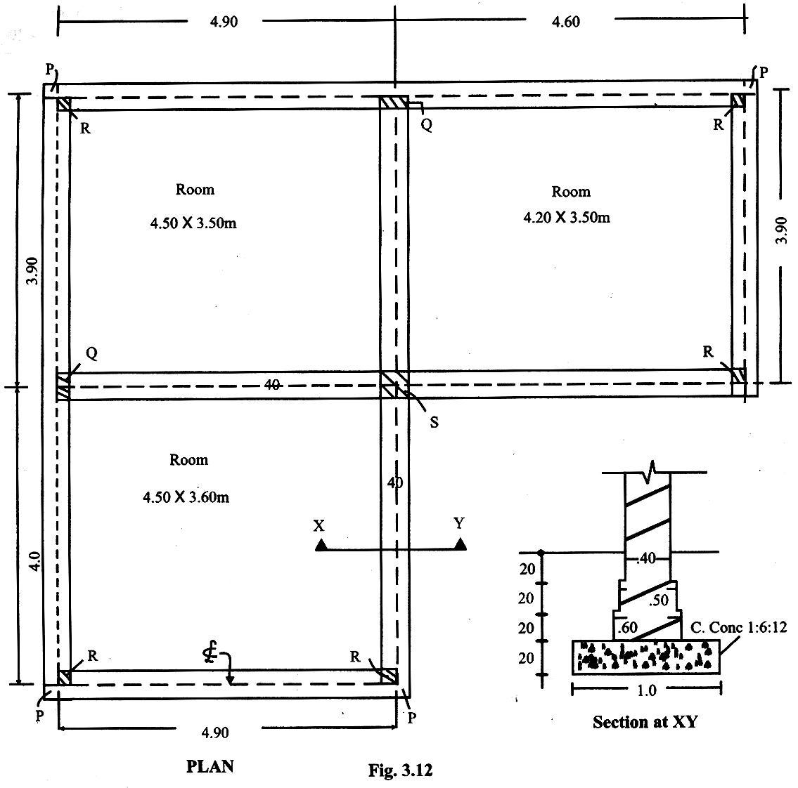

Solution:

(a) BY CENTRE LINE METHOD

ESTIMATES

|  |  |  |  |  |  |  |  |  |  |  |  |  |  |  |  |  |  |
| --- | --- | --- | --- | --- | --- | --- | --- | --- | --- | --- | --- | --- | --- | --- | --- | --- | --- |
|  |  |  |  |  |  |  |  |  |  |  |  |  |  |  |  |  |  |
|  |  |  |  |  |  |  |  | Measurements | | | | |  |  |  |  |  |
|  |  | Detail of Work |  | No. | |  |  |  |  |  |  |  |  | Contents | |  |  |
|  |  |  |  |  |  |  |  |  |  |  |  |  |  |  |  |  |  |
|  |  |  |  |  |  |  | L |  |  | B |  | H |  |  |  |  |  |
|  |  |  |  |  |  |  |  | |  |  |  |  |  |  |  |  |  |
|  |  |  |  |  |  |  | | |  |  |  |  | | |  |  |  |
|  |  |  |  |  |  | (**a) BY CENTRE LINE METHOD** | | | | | | | | |  |  |  |
|  | **1.** | **Excavation for foundations** |  |  |  |  |  |  |  |  |  |  |  |  |  |  |  |
|  |  |  |  |  |  |  |  |  |  |  |  |  |  |  |  |
|  |  |  |  | 1 |  |  | 42.8 |  |  | 1.0 |  | 0.80 |  | 34.26 |  |  |  |
|  | Total | |  | cub. m. | |  |  |  |  |  |  |  |  | = |  |  |  |
|  | **2.** | **C. Concrete in foundation** |  | 1 |  |  | 42.8 |  |  | 1.0 |  | 0.20 |  | 34.24 |  |  |  |
|  |  |  |  | cub. m. | |  |  |  |  |  |  |  |  | 8.56 |  |  |  |
|  |  |  |  |  |  |  |  |  |  |  |  |  |  |  |  |  |  |



|  |  |  |  |  |  |  |  |  |  |  |  |  |  |  |  |  |  |  |  |  |  |  |  |  |  |
| --- | --- | --- | --- | --- | --- | --- | --- | --- | --- | --- | --- | --- | --- | --- | --- | --- | --- | --- | --- | --- | --- | --- | --- | --- | --- |
|  |  |  |  |  |  |  |  |  |  |  |  |  |  |  |  |  |  |  |  |  |  |  |  |  |  |
|  | Total |  |  |  |  |  |  |  |  |  | = | |  |  |  |  |  |  |  |  |  |  |  |  |  |
|  | **3. B. Brick in Cement mortar** ( |  | 1 |  | 42.8 |  | 0.60 |  | 0.20 |  | 8.56 | | | | | | |  |  |  |  |  |  |  |  |
|  | 1:4 ) |  | 1 |  | 42.8 |  | 0.50 |  | 0.20 |  |  |  |  |  |  |  |  |  |  |  |  |  |  |  |  |
|  | 1st. step |  | 1 |  | 42.8 |  | 0.40 |  | 0.20 |  | 5.13 | | | | | | | | | | | |  |  |  |
|  | 2nd.step |  |  |  |  |  |  |  |  |  | 4.28 | | | | | | | | | | | |  |  |  |
|  | 3rd.step |  |  |  |  |  |  |  |  |  | 3.42 | | | | | | | | | | | |  |  |  |
|  |  |  | cub. m. |  |  |  |  |  |  |  | ________ | | | | | | | | | | | | | |  |
|  |  |  |  |  |  |  |  |  |  |  |  |  |  |  |  |  |  |  |  |  |  |  |  |  |  |
|  |  |  |  |  |  |  |  |  |  |  | __ | | |  |  |  |  |  |  |  |  |  |  |  |  |
|  |  |  |  |  |  |  |  |  |  |  |  | 12.83 | | | | | | | | | | | | |  |
|  |  |  |  |  |  |  |  |  |  |  | = | |  |  |  |  |  |  |  |  |  |  |  |  |  |
|  | Total |  |  |  |  |  |  |  |  |  | **12.83** | | | | | | | | |  |  |  |  |  |  |
|  |  |  |  |  |  |  |  |  |  |  |  |  |  |  |  |  |  |  |  |  |  |  |  |  |  |
|  |  |  |  |  |  |  |  |  |  |  |  |  |  |  |  |  |  |  |  |  |  |  |  |  |  |

by) BY CROSSING METHOD

1. Excavation for foundations

|  |  |  |  |  |  |  |  |  |  |  |  |  |  |  |
| --- | --- | --- | --- | --- | --- | --- | --- | --- | --- | --- | --- | --- | --- | --- |
|  | Top Rooms | Long Walls |  |  |  |  |  |  |  |  |  |  |  |  |
|  | (.40 + 4.50 + .40 + 4.20 + .40) = 9.90 | | 2 | 9.9 | 1.0 | 0.80 | 15.84 | | | | | | |  |
|  |  | Short walls | 3 | 3.5 | 1.0 | 0.80 | 8.40 | | | | | | |  |
|  | *Bottom Room* | Long walls | 1 | 5.3 | 1.0 | 0.80 | 4.24 | | | | | | |  |
|  | (.40 + 4.50 + .40 =5.30) | |  |  |  |  |  |  |  |  |  |  |  |  |
|  |  | Short walls | 2 | 3.6 | 1.0 | 0.80 | 5.76 | | | | | | |  |
|  |  |  |  |  |  |  | _____ | | | | | | |  |
|  |  |  |  |  |  |  |  |  |  |  |  |  |  |  |
|  |  |  |  |  |  |  | 34.24 | | | | | | |  |
|  |  | Total | cub. |  |  |  | **34.24** | | | | | | | |
| 2. | C. Concrete in foundations | | m. |  |  |  |  |  |  |  |  |  |  |  |
|  | *Top Rooms* | Long Walls |  | 9.9 | 1.0 | 0.20 | 3.96 | | | | | | |  |
|  |  | Short walls | 2 | 3.5 | 1.0 | 0.20 | 2.10 | | | | | | |  |
|  |  |  | 2 |  |  |  |  |  |  |  |  |  |  |  |
|  | *Bottom Room* | Long walls |  | 5.3 | 1.0 | 0.20 | 1.06 | | | | | | |  |
|  |  | Short walls | 1 | 3.6 | 1.0 | 0.20 | 7.44 | | | | | | |  |
|  |  |  | 2 |  |  |  | _____ | | | | | | |  |
|  |  |  |  |  |  |  |  |  |  |  |  |  |  |  |
|  |  |  |  |  |  |  | 8.56 | | | | | | |  |
|  |  | Total |  |  |  |  | **8.56** | | | | | | | |
| 3. | B. Brick in cement mortar | | cub. |  |  |  |  |  |  |  |  |  |  |  |
|  | *Top Rooms* |  | m. |  |  |  |  |  |  |  |  |  |  |  |
|  | Long Walls | 1st. step |  | 9.90 | 0.60 | 0.20 | 2.38 | | | | | | |  |
|  |  | 2nd.step |  | 9.90 | 0.50 | 0.20 | 1.98 | | | | | | |  |
|  |  | 3rd.step | 2 | 9.90 | 0.40 | 0.20 | 1.58 | | | | | | |  |
|  |  |  | 2 |  |  |  |  |  |  |  |  |  |  |  |
|  | Short walls | 1st. step | 2 | 3.50 | 0.60 | 0.20 | 1.26 | | | | | | |  |
|  |  | 2nd.step |  | 3.50 | 0.50 | 0.20 | 1.05 | | | | | | |  |
|  |  | 3rd.step | 3 | 3.50 | 0.40 | 0.20 | 0.84 | | | | | | |  |
|  | *Bottom Room* |  | 3 |  |  |  |  |  |  |  |  |  |  |  |
|  | Long walls | 1st. step | 3 | 5.30 | 0.60 | 0.20 | 0.64 | | | | | | |  |
|  |  | 2nd.step |  | 5.30 | 0.50 | 0.20 | 0.53 | | | | | | |  |
|  |  |  | 1 |  |  |  |  |  |  |  |  |  |  |  |
|  |  |  | 1 |  |  |  |  |  |  |  |  |  |  |  |



ESTIMATES & COSTING

|  |  |  |  |  |  |  |  |  |  |  |  |  |  |  |  |  |  |  |  |  |  |  |
| --- | --- | --- | --- | --- | --- | --- | --- | --- | --- | --- | --- | --- | --- | --- | --- | --- | --- | --- | --- | --- | --- | --- |
|  |  |  |  |  |  |  |  |  |  |  |  |  |  |  |  |  |  |  |  |  |  |  |
|  |  |  |  |  |  |  | Measurements | | | | |  |  |  |  |  |  |  |  |  |  |  |
|  | Detail of Work |  |  | No. |  |  |  |  |  |  |  |  |  |  |  |  |  |  |  |  | Contents |  |
|  |  |  |  |  |  |  |  |  |  |  |  |  |  |  |  |  |  |  |  |  |  |  |
|  |  |  |  |  |  | L |  |  | B |  |  | H |  |  |  |  |  |  |  |  |  |  |
|  |  |  |  |  |  |  |  |  |  |  |  |  |  |  | | | | | | |  |  |
|  |  |  |  |  |  | |  |  |  |  |  |  |  | | | | | | | |  |  |
|  |  | 3 rd step |  | 1 |  | 5.30 |  |  | 0.40 |  |  | 0.20 |  | 0.42 | | | | | | |  |  |
|  | Short Walls | 1 st step |  | 2 |  | 3.60 |  |  | 0.60 |  |  | 0.20 |  | 0.86 | | | | | | |  |  |
|  |  | 2 nd. Step |  | 2 |  | 3.60 |  |  | 0.50 |  |  | 0.20 |  | 0.72 | | | | | | |  |  |
|  |  | 3rd. step |  | 2 |  | 3.60 |  |  | 0.40 |  |  | 0.20 |  | 0.58 | | | | | | |  |  |
|  |  |  |  |  |  |  |  |  |  |  |  |  |  | _____ | | | | | | | |  |
|  |  |  |  |  |  |  |  |  |  |  |  |  |  |  |  |  |  |  |  |  |  |  |
|  |  |  |  |  |  |  |  |  |  |  |  |  |  | 12.83 | | | | | | | |  |
|  |  | Total |  | cub. m. |  |  |  |  |  |  |  |  |  | **12.83** | | | | | | | |  |
|  |  |  |  |  |  |  |  |  |  |  |  |  |  |  |  |  |  |  |  |  |  |  |
|  |  |  |  |  |  |  |  |  |  |  |  |  |  |  |  |  |  |  |  |  |  |  |



As already discussed, in this method, the length of centre line is fixed once for all and

this is used or calculating quantities of various items. The only requirement for the uses

for this method is that the section of walls should be symmetrical throughout.

How to Fix Centre Line.

The Centre line of the given plain marked and centre to centre distances of walls are

added. Refer given figure 3.12, the total length of centre line, room-wise is as under from

top right corner.

All horizontal – 4.60 + 4.90 + 4.90 + 4.60 + 4.90=23.90

All vertical – 3.90 + 3.90 + 3.90 + 4.0 + 4.0=19.70

But there are hatched rectangles showing that these portions have been added twice i.e. this portion is part of both the lines meeting at rt. Angle to each other. So this portion is to be added only once.

The deductions to be made are as under:-

1. At L-junction Walls

At L-junction, two squares P & R are formed. The hatched portion R‟ comes twice, whereas portion „P‟ does not come even once. So „P‟ is compensated with „R‟ coming twice. Thus in the case of L-junction, no deduction is to be done from the total length of centre line.

* 1. At L-junction Walls.

In this case, the hatched rectangular portion „Q‟ comes twice. So the deduction in this case is ½ of thickness of wall for each T-junction.

1. At Cross Walls.

In this case also, the hatched square portion „S‟ comes twice. So, for correct calculations, it is to be added only once. Thus for a cross wall, the deducaiton is thickness of wall.

Form above lines we have found out this conclusion that to get the correct length of the centre line, the following deductions are to be made:-

½ * thickness of the wall at T-junction * No. of junctions

+ 1 * thickness of wall at cross-junction * no. junctions

=1/2 *.40*2+1*.40*1 =0.80m.

=43.60-0.80=42.80m.

All the quantities shall be calculated using 42.80m. as length of centre line.

**DETAILED ESTIMATES**

**WINDOW IN AN EXISTING WALL**

We have learnt from the previous chapter, the methods of calculating various quantities. In this chapter, estimates of buildings have dealt in details, complete with Report, Specifications, Abstract of cost and Material statement. The rates applied for calculating the abstract of cost are the approved ones, as are in schedule or rates of Punjab & Haryana. The current premium above C.S.R. has also been incorporated in the rate. Before starting with Detailing, the few important points about estimating which should be known are as under: these points are common for any type of civil engineering structure.

IMPORTANT POINTS ABOUT ESTIMATING

1. Before starting any estimate of building, road and bridge, it should be seen that the plans are fully dimensioned , inner and outer dimensions should be checked before starting the estimate to avoid complications later on.
2. The estimate should be drawn sub-head-wise, to avoid omission of any item.
3. The nomenclature of every item should be according to the sanctioned schedule of rates to avoid claims of the contractors later on.
4. All items should be calculated in units, according to which the payment is to to be made (chapter on, units)
5. A detailed report according to the sub-heads should be attached. This should be self explanatory giving complete information.

1. Detailed drawings should be attached with every detailed estimate, with north line on the plan.
2. Detailed specifications of every item should be attached so that the work should be carried out accordingly & the specifications should be according to the latest edition of the P.W.D. specifications.
3. In order to make the estimate a comprehensive one, provision of electric & water supply should be made.
4. In the end of estimate, an abstract of cost giving cost of every sub-head and total cost should be attached. A provision of contingencies & petty establishment @ 5% should be added in the end of abstract of cost.
5. The rate per sq. metre should be worked out & it should be given in the end of abstract of the building estimate. This helps in future reference.
6. In case of Road estimate, rate per Km. should also be worked out.
7. The road estimate should mention the special features of the alignment so followed & also whether the soling is of bricks or of stone, should be mentioned in the report of estimate.
8. In case of bridges & culverts, rate per metre (width) to be worked out.
9. Current applicable premium above C.S.R. should be added before finding out the unit rate i.e., plinth or per km rate.

DATA REQUIRED FOR PREPARATION OF AN ESTIAMTE

1. Complete and fully dimensioned plans & sections of the work of question.
2. Detailed specifications, giving the nature and class of work and material to be used.
3. Rates for calculating abstract of cost. These should be approved ones. Premium above C.S.R., as prevailing at the time of finding cost should also be added.

**Problem-2**

Calculate the following items from the plan and section given in the fig.3.13 using

centre line method:

(i) Excavation for foundations.

(ii)Cement Concrete (1:6:18) in foundations.

(iii) Brick Work in cement mortar (1:6) in foundations and plinth.

Sol: Total length of the wall along the centre line

5.20+ 4.40 + 4.40 + 4.40 +2.12 + 2.12 +2.12+2.20+2.20 = 20.44 say 20.50m.

4.80+.40 = 5.20

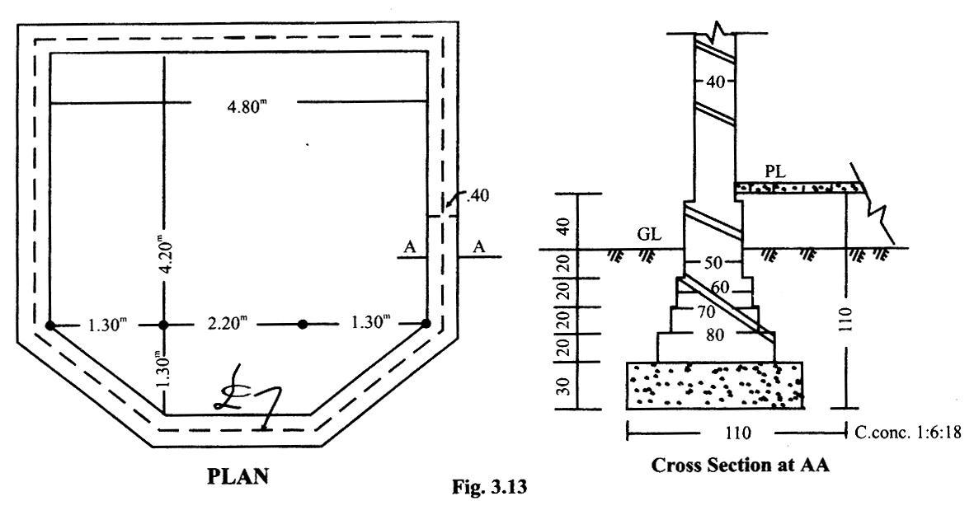

ESTIMATES

|  |  |  |  |  |  |  |  |  |  |  |  |  |  |  |  |
| --- | --- | --- | --- | --- | --- | --- | --- | --- | --- | --- | --- | --- | --- | --- | --- |
|  |  |  |  |  |  |  |  |  |  |  |  |  |  |  |  |
|  |  |  |  |  |  | Measurements | | | | |  |  |  |  |  |
|  |  | Detail of Work |  | No. |  |  |  |  |  |  |  |  |  | Contents |  |
|  |  |  |  |  |  |  |  |  |  |  |  |  |  |  |  |
|  |  |  |  |  |  | L |  | B |  |  | H |  |  |  |  |
|  |  |  |  |  |  |  |  |  |  |  |  |  |  |  |  |
|  |  |  |  |  |  |  |  |  |  |  |  |  |  |  |  |
|  | 1. | Excavation for foundations | 1 | | 20.50 | | 1.10 | |  |  | 1.10 |  |  | 24.80 |  |
|  |  | Total |  | cub. m. |  |  |  |  |  |  | = | | | **24.80** |  |
|  | 2. | Cement. Concrete in foundation | 1 | | 20.50 | | 1.10 | |  |  | .30 |  |  | 6.80 |  |
|  |  | (1:6:18) |  |  |  |  |  |  |  |  |  |  |  |  |  |
|  |  | Total |  | cub. m. |  |  |  |  |  |  | = | | | 6.80 |  |

1. **Brick work** in Cement mortar ( 1:6 )in foundation and plinth

|  |  |  |  |  |  |  |  |  |  |  |  |  |  |  |  |  |  |  |  |  |  |  |  |  |  |
| --- | --- | --- | --- | --- | --- | --- | --- | --- | --- | --- | --- | --- | --- | --- | --- | --- | --- | --- | --- | --- | --- | --- | --- | --- | --- |
|  |  |  |  |  |  |  |  |  |  |  |  |  |  |  |  |  |  |  |  |  |  |  |  |  |  |
|  | 1 st. step |  | 1 |  | 20.50 |  | .80 |  | 0.20 |  |  | 3.28 | | | | | | | | | | |  |  |  |
|  | 2 nd.step |  | 1 |  | 20.50 |  | .70 |  | 0.20 |  |  | 2.87 | | | | | | | | | | |  |  |  |
|  | 3 rd.step |  | 1 |  | 20.50 |  | .60 |  | 0.20 |  |  | 2.46 | | | | | | | | | | |  |  |  |
|  | 4 th. step |  | 1 |  | 20.50 |  | .50 |  | 0.20 |  |  | 6.15 | | | | | | | | | | |  |  |  |
|  |  |  |  |  |  |  |  |  |  |  |  | _______ | | | | | | | | | | | | |  |
|  |  |  |  |  |  |  |  |  |  |  |  |  |  |  |  |  |  |  |  |  |  |  |  |  |  |
|  |  |  |  |  |  |  |  |  |  |  |  |  |  | 14.76 | | | | | | | | | |  |  |
|  | Total |  | cub. m. |  |  |  | SAY |  |  |  | = | **14.80** | | | | | | | | | | | | |  |
|  |  |  |  |  |  |  |  |  |  |  |  |  |  |  |  |  |  |  |  |  |  |  |  |  |  |



Prepare a detailed estimate of a shop shown in fig and calculate its cost with approved rates. Also find out the plinth area rate of the shop.

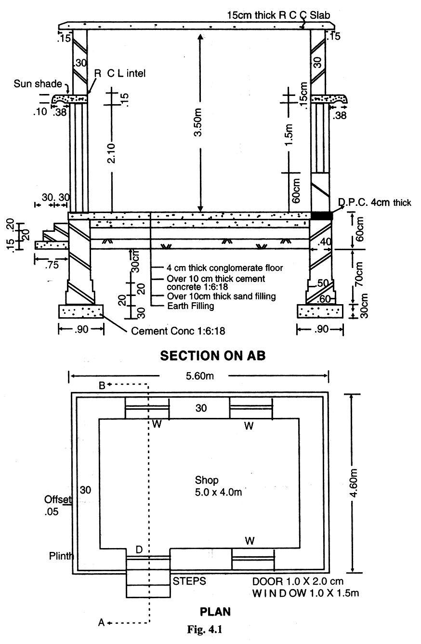



**SOLUTION**

|  |  |  |  |  |  |  |  |  |  |  |  |  |  |  |  |  |  |  |  |  |  |  |  |  |  |  |  |  |  |  |  |  |
| --- | --- | --- | --- | --- | --- | --- | --- | --- | --- | --- | --- | --- | --- | --- | --- | --- | --- | --- | --- | --- | --- | --- | --- | --- | --- | --- | --- | --- | --- | --- | --- | --- |
| Detail of Work |  |  | No. |  |  | Measurements | | |  |  |  | Qty. | | | | | | |  | Remarks | | | | | | | | | | | | |
|  |  |  |  |  |  |  |  |  |  |  |  |  |  |  |  |  |  |  |  |  |  |  |  |  |  |  |  |  |  |  |  |  |
|  |  |  |  |  | L |  |  | B |  | H |  |  |  |  |  |  |  |  |  |  |  |  |  |  |  |  |  |  |  |  |  |  |
|  | |  |  |  |  |  |  |  |  |  |  |  |  |  |  |  |  |  |  |  |  |  |  |  |  |  |  |  |  |  |  |  |
|  | |  |  |  |  |  |  |  |  |  |  |  |  |  |  |  |  |  |  |  |  |  |  |  |  |  |  |  |  |  |  |  |
| **Sub-Head I EARTH WORK** | |  |  |  |  |  |  |  |  |  |  |  |  |  |  |  |  |  |  |  |  |  |  |  |  |  |  |  |  |  |  |  |
|  |  |  |  |  |  |  |  |  |  |  |  |  |  |  |  |  |  |  |  | *Refer Fig*. 4.1 | | | | | | | | | | | | |
|  | |  |  |  |  |  |  |  |  |  |  |  |  |  |  |  |  |  |  |  |  |  |  |  |  |  |  |  |  |  |  |  |
| **1. Excavation for foundations** | |  |  |  |  |  |  |  |  |  |  |  |  |  |  |  |  |  |  |  |  |  |  |  |  |  |  |  |  |  |  |  |
| Long walls |  |  | 2 |  | 6.20 |  |  | .90 |  | 1.0 |  | 11.16 | | | | | | |  | 5.60+.60=6.20 | | | | | | | | | | | | |
| Short walls |  |  | 2 |  | 3.40 |  |  | .90 |  | 1.0 |  | 6.12 | | | | | | |  | 4.0-.60=3.40 | | | | | | | | | | |  |  |
| Steps in front of door | |  | 1 |  | 1.30 |  |  | .75 |  | .15 |  | .15 | | | | | |  |  | 1+.30=1.30 | | | | | | | | |  |  |  |  |
|  |  |  |  |  |  |  |  |  |  |  |  | ____ | | | | | | |  |  |  |  |  |  |  |  |  |  |  |  |  |  |
|  |  |  |  |  |  |  |  |  |  |  |  |  |  |  |  |  |  |  |  |  |  |  |  |  |  |  |  |  |  |  |  |  |
|  |  |  |  |  |  |  |  |  |  |  |  | 17.43 | | | | | | |  |  |  |  |  |  |  |  |  |  |  |  |  |  |
|  | Total |  |  |  | cub. m. | |  |  |  | say |  |  |  |  |  |  |  |  |  | =17.50 | |  |  |  |  |  |  |  |  |  |  |  |
| **Sub-Head II CONCRETE** | |  |  |  |  |  |  |  |  |  |  |  |  |  |  |  |  |  |  |  |  |  |  |  |  |  |  |  |  |  |  |  |
| **2. Cement Concrete in foundations** | |  |  |  |  |  |  |  |  |  |  |  |  |  |  |  |  |  |  |  |  |  |  |  |  |  |  |  |  |  |  |  |
| **(1:6:18)** |  |  |  |  |  |  |  |  |  |  |  |  |  |  |  |  |  |  |  |  |  |  |  |  |  |  |  |  |  |  |  |  |
| Long walls |  |  | 2 |  | 6.20 |  |  | .90 |  | .30 |  | 3.35 | | | | | | |  |  |  |  |  |  |  |  |  |  |  |  |  |  |
| Short walls |  |  | 2 |  | 3.40 |  |  | .90 |  | .30 |  | 1.84 | | | | | | |  |  |  |  |  |  |  |  |  |  |  |  |  |  |
| Steps |  |  | 1 |  | 1.30 |  |  | .75 |  | .15 |  | .15 | | | | | |  |  |  |  |  |  |  |  |  |  |  |  |  |  |  |
|  |  |  |  |  |  |  |  |  |  |  |  | ____ | | | | | | |  |  |  |  |  |  |  |  |  |  |  |  |  |  |
|  |  |  |  |  |  |  |  |  |  |  |  |  |  |  |  |  |  |  |  |  |  |  |  |  |  |  |  |  |  |  |  |  |
|  |  |  |  |  |  |  |  |  |  |  |  | 5.34 | | | | | | |  |  |  |  |  |  |  |  |  |  |  |  |  |  |
|  | Total |  |  |  | cub. m. | |  |  |  |  |  |  |  |  |  |  |  |  |  | =5.34 |  |  |  |  |  |  |  |  |  |  |  |  |
| **3. Reinforced Cement Concrete** | |  |  |  |  |  |  |  |  |  |  |  |  |  |  |  |  |  |  |  |  |  |  |  |  |  |  |  |  |  |  |  |
| **(1:2:4)** |  |  |  |  |  |  |  |  |  |  |  |  |  |  |  |  |  |  |  |  |  |  |  |  |  |  |  |  |  |  |  |  |
| **Lintels** |  |  |  |  |  |  |  |  |  |  |  |  |  |  |  |  |  |  |  |  |  |  |  |  |  |  |  |  |  |  |  |  |
| Door | (1.0 m. x 2.10 m.) |  | 1 |  | 1.30 |  |  | .30 |  | .15 |  | .06 | | | | | |  |  | A = .24 sq.m. | | | | | | | | | | | | |
| Windows | (1.0 m. x 1.5 m.) |  | 3 |  | 1.30 |  |  | .30 |  | .15 |  | .18 | | | | | |  |  | Bearing 15 cm. | | | | | | | | | | | | |
| **Sun-shades.** |  |  |  |  |  |  |  |  |  |  |  |  |  |  |  |  |  |  |  |  |  |  |  |  |  |  |  |  |  |  |  |  |
| Door |  |  | 1 |  | 1.30 |  |  | .38 |  | .12 |  | .06 | | | | | |  |  | .15+.10 | | | | | | | | | | | | |
|  |  |  |  |  |  |  |  |  |  |  |  |  |  |  |  |  |  |  |  | _______ | | | | | | | | | | | | |
| =.12 |  |  |  |  |  |  |  |  |  |  |  |  |  |  |  |  |  |  |  |  |  |  |  |  |  |  |  |  |  |  |  |  |
| Window |  |  | 3 |  | 1.30 |  |  | .38 |  | .12 |  | .18 | | | | | |  |  | 2 | | | | | | | | | |  |  |  |
|  |  |  |  |  |  |  |  |  |  |  |  | ____ | | | | | | |  |  |  |  |  |  |  |  |  |  |  |  |  |  |
|  |  |  |  |  |  |  |  |  |  |  |  |  |  |  |  |  |  |  |  |  |  |  |  |  |  |  |  |  |  |  |  |  |
|  |  |  |  |  |  |  |  |  |  |  |  | .48 | | | | | |  |  |  |  |  |  |  |  |  |  |  |  |  |  |  |
| **Roof Slab:** | B.F. |  |  |  |  |  |  | cub. m. |  |  |  | 0.48 | | | | | | |  |  |  |  |  |  |  |  |  |  |  |  |  |  |
| Room |  |  | 1 |  | 5.90 |  |  | 4.90 |  | .15 |  | 4.33 | | | | | | |  | 5.0+.60+.15+.15 | | | | | | | | | | | | |
|  |  |  |  |  |  |  |  |  |  |  |  | ____ | | | | | | |  | =5.90 |  |  |  |  |  |  |  |  |  |  |  |  |
|  |  |  |  |  |  | |  |  |  |  |  |  |  |  |  |  |  |  |  |  |  |  |  |  |  |  |  |  |  |  |  |  |
|  | Total |  |  |  | cub. m. | |  |  |  |  |  | 4.81 | | | | | | |  | =4.81 |  |  |  |  |  |  |  |  |  |  |  |  |
| **4. Damp proof course,** 4 cm. thick of | |  | 2 |  | 5.70 |  |  | .35 |  | – |  | 3.99 | | | | | | |  | 5.0+.30+.30+.05+ | | | | | | | | | | | | |
| cement concrete (1:2:4) with 2 | |  |  |  |  |  |  |  |  |  |  |  |  |  |  |  |  |  |  | .05=5.70 | | | | |  |  |  |  |  |  |  |  |
| coats of biumen. | |  | 2 |  | 4.00 |  |  | .35 |  | – |  | 2.80 | | | | | | |  |  |  |  |  |  |  |  |  |  |  |  |  |  |
| Long walls |  |  |  |  |  |  |  |  |  |  |  | ____ | | | | | | |  |  |  |  |  |  |  |  |  |  |  |  |  |  |
|  |  |  |  |  |  |  |  |  |  |  |  |  |  |  |  |  |  |  |  |  |  |  |  |  |  |  |  |  |  |  |  |  |
|  |  |  |  |  |  |  |  |  |  |  |  | 6.79 | | | | | | |  | where .05=plinth | | | | | | | | | | | | |
| Short walls |  |  |  |  |  |  |  |  |  |  |  |  |  |  |  |  |  |  |  | offset | | | | | | | | | | | | |

|  |  |  |  |  |  |  |  |  |  |  |  |  |  |  |  |  |  |  |  |
| --- | --- | --- | --- | --- | --- | --- | --- | --- | --- | --- | --- | --- | --- | --- | --- | --- | --- | --- | --- |
|  |  |  |  |  |  |  |  |  |  |  |  |  |  |  |  |  |  |  |  |
|  | **Deduct** |  |  |  |  |  |  |  |  |  |  |  |  |  |  |  |  |  |  |
|  | Door(1.0 m. x 2.10 m.) |  | 1 |  | 1.00 |  | .35 |  | – |  |  | 0.35 | | | | |  |  |  |
|  |  |  |  |  |  |  |  |  |  |  |  | ____ | | | | |  |  |  |
|  |  |  |  |  |  |  |  |  |  |  |  |  |  |  |  |  |  |  |  |
|  |  |  |  |  |  |  |  |  |  |  |  | 6.44 | | | | |  |  |  |
|  | Total |  |  |  | sq. m. |  |  |  |  |  |  | say | | | | |  | = 6.50 |  |
|  | **Sub-Head IIICONCRETE** |  |  |  |  |  |  |  |  |  |  |  |  |  |  |  |  |  |  |
|  |  |  |  |  |  |  |  |  |  |  |  |  |  |  |  |  |  |  |  |



|  |  |  |  |  |  |  |  |  |  |  |  |  |  |  |  |  |  |  |  |  |
| --- | --- | --- | --- | --- | --- | --- | --- | --- | --- | --- | --- | --- | --- | --- | --- | --- | --- | --- | --- | --- |
|  |  |  |  |  |  |  |  |  |  |  |  |  |  |  |  |  |  |  |  |  |
|  | **5. B.B. in mud mortar in foundations** | |  |  |  |  |  |  |  |  |  |  |  |  |  |  |  |  |  |  |
|  | **and plinth** |  |  |  |  |  |  |  |  |  |  |  |  |  |  |  |  |  |  |  |
|  | Long walls | 1st. step |  | 2 |  | 5.90 |  | .60 |  | .20 |  |  | 1.41 | | | | |  | 5.60+.30=5.90 |  |
|  |  | 2 nd.step |  | 2 |  | 5.80 |  | .50 |  | .20 |  |  | 1.16 | | | | |  | 5.60+.20=5.80 |  |
|  |  | 3 rd.step |  | 2 |  | 5.70 |  | .40 |  | .90 |  |  | 4.10 | | | | |  | 5.60+.10=5.70 |  |
|  | Short walls | 1st. step |  | 2 |  | 3.70 |  | .60 |  | .20 |  |  | .89 | | | | |  |  |  |
|  |  | 2 nd.step |  | 2 |  | 3.80 |  | .50 |  | .20 |  |  | .76 | | | | |  |  |  |
|  |  | 3 rd.step |  | 2 |  | 3.90 |  | .40 |  | .90 |  |  | 2.80 | | | | |  |  |  |
|  | Steps in front of Door, | 1st. step |  | 1 |  | 1.00 |  | .60 |  | .20 |  |  | .12 | | | | |  |  |  |
|  |  | 2 nd.step |  | 1 |  | 1.00 |  | .30 |  | .20 |  |  | .06 | | | | |  |  |  |
|  |  |  |  |  |  |  |  |  |  |  |  |  | ____ | | | | |  |  |  |
|  |  |  |  |  |  |  |  |  |  |  |  |  |  |  |  |  |  |  |  |  |
|  |  |  |  |  |  |  |  |  |  |  |  |  | 11.30 | | | | |  |  |  |
|  | **Deduct** |  |  |  |  |  |  |  |  |  |  |  |  |  |  |  |  |  |  |  |
|  | D.P.C vide item 4 above | |  | 1 |  | 6.50 |  | x.04 |  |  |  |  | .26 | | | | |  |  |  |
|  |  | Total |  |  |  | cub. m. |  |  |  |  |  |  |  |  |  |  |  |  | =11.04 |  |
|  | **6. B.B. in mud mortar in** |  |  |  |  |  |  |  |  |  |  |  |  |  |  |  |  |  |  |  |
|  | **superstructure** |  |  |  |  |  |  |  |  |  |  |  |  |  |  |  |  |  |  |  |
|  | Long walls |  |  | 2 |  | 5.60 |  | .30 |  | 3.5 |  |  | 11.76 | | | | |  |  |  |
|  | Short walls |  |  | 2 |  | 4.00 |  | .30 |  | 3.5 |  |  | 8.40 | | | | |  |  |  |
|  |  |  |  |  |  |  |  |  |  |  |  |  | ____ | | | | |  |  |  |
|  |  |  |  |  |  |  |  |  |  |  |  |  |  |  |  |  |  |  |  |  |
|  | **Deduct** |  |  |  |  |  |  |  |  |  |  |  | 20.46 | | | | |  |  |  |
|  | Door |  |  | 1 |  | 1.00 |  | .30 |  | 2.1 |  |  | .63 | | | | |  |  |  |
|  | Windows |  |  | 3 |  | 1.00 |  | .30 |  | 1.5 |  |  | 1.35 | | | | |  |  |  |
|  | R.C.C. lintels marked A in items ( 3 ) | |  |  |  |  |  |  |  |  |  |  | .24 | | | | |  |  |  |
|  |  |  |  |  |  |  |  |  |  |  |  |  | ____ | | | | |  |  |  |
|  |  |  |  |  |  |  |  |  |  |  |  |  |  |  |  |  |  |  |  |  |
|  |  |  |  |  |  |  |  |  |  |  |  |  | 2.22 | | | | |  |  |  |
|  |  |  |  |  |  |  |  |  |  |  |  |  | ____ | | | | |  |  |  |
|  |  |  |  |  |  |  |  |  |  |  |  |  |  |  |  |  |  |  |  |  |
|  |  |  |  |  |  |  |  |  |  |  |  |  | 17.24 | | | | |  |  |  |
|  |  | Total |  |  |  | cub. m. |  | *Say |  |  |  |  |  |  |  |  |  |  | = 18.00 |  |
|  | **SUB-HEAD IV FLOORING** | |  |  |  |  |  |  |  |  |  |  |  |  |  |  |  |  |  |  |
|  | **7. Conglomerate floor,** 4 cm. thick over | |  |  |  |  |  |  |  |  |  |  |  |  |  |  |  |  |  |  |
|  | 10 cm. thick cement concrete over 10 cm. | |  |  |  |  |  |  |  |  |  |  |  |  |  |  |  |  |  |  |
|  | thick sand. |  |  |  |  |  |  |  |  |  |  |  |  |  |  |  |  |  |  |  |
|  | Room |  |  | 1 |  | 5.0 |  | 4.0 |  | – |  |  | 20.0 | | | | |  |  |  |
|  |  | Total |  | sq.m. |  |  |  |  |  |  |  |  |  |  |  |  |  |  | = 20.00 |  |
|  |  |  |  |  |  |  |  |  |  |  |  |  |  |  |  |  |  |  |  |  |
|  |  |  |  |  |  |  |  |  |  |  |  |  |  |  |  |  |  |  |  |  |



*At certain *places, the quantities coming in fraction are made round figures, keeping in* *mind the wastage due to handling. But not for steel and* R.C.C



|  |  |  |  |  |  |  |  |  |  |  |  |  |  |  |  |  |  |  |  |  |  |  |  |  |
| --- | --- | --- | --- | --- | --- | --- | --- | --- | --- | --- | --- | --- | --- | --- | --- | --- | --- | --- | --- | --- | --- | --- | --- | --- |
|  |  |  |  |  |  | Measurements | | | | |  |  | Qty. | | | | | | | |  | Remarks | |  |
|  |  |  | No. |  |  |  |  |  |  |  |  |  |  |  |  |  |  |  |  |  |  |  |  |  |
|  |  |  |  | L |  |  | B |  | H |  |  |  |  |  |  |  |  |  |  |  |  |  |  |
|  |  |  |  |  |  |  |  |  |  |  |  |  |  |  |  |  |  |  |  |  |  |
| Detail of Work | |  |  |  |  |  |  |  |  |  |  |  |  |  |  |  |  |  |  |  |  |  |  |  |
|  | |  |  |  |  |  |  |  |  |  |  |  |  |  |  |  |  |  |  |  |  |  |  |  |
| **7. (a) Topping,** 4 cm. thick of | |  |  |  |  |  |  |  |  |  |  |  |  |  |  |  |  |  |  |  |  |  |  |  |
| cement | concrete (1:2:4) |  |  |  |  |  |  |  |  |  |  |  |  |  |  |  |  |  |  |  |  |  |  |  |
| Door |  | 1 | | 1.00 | | .35 | | |  | – | 0.35 | | | | | | | | |  |  |  |  |  |
|  |  |  | sq.m. |  |  |  |  |  |  |  |  |  |  |  |  |  |  |  |  |  | = 0.35 | |  |  |
| Total |  |  |  |  |  |  |  |  |  |  |  |  |  |  |  |  |  |  |  |  |  |  |  |  |
| **SUB-HEAD V WOOD WORK** | |  |  |  |  |  |  |  |  |  |  |  |  |  |  |  |  |  |  |  |  |  |  |  |
| **8. Deodar wood** doors and windows | | 1 | | 1.00 | |  |  | – | 2.1 | | 2.1 | | | | | | |  |  |  |  |  |  |  |
| Door |  | 3 | | 1.00 | |  |  | – | 1.5 | | 4.5 | | | | | | |  |  |  |  |  |  |  |
| Windows |  |  |  |  |  |  |  |  |  |  |  | | ____ | | | | | | | |  |  |  |  |
|  |  |  |  |  |  |  |  |  |  |  |  | |  |  |  |  |  |  |  |  |  | |  |  |
|  |  |  | sq.m. |  |  |  |  |  |  |  |  | | 6.6 | | | | |  |  |  | = 6.6 | |  |  |
| Total |  |  |  |  |  |  |  |  |  |  |  |  |  |  |  |  |  |  |  |  |  |  |  |  |
| **SUB-HEAD VI FINISHING** | | 1 | | 18.00 | |  |  | – | 3.5 | | 63.00 | | | | | | | | | | 5+5+4+4= 18.00 | | |  |
| **9. Cement plaster 1.25 cm. thick** | |  |  |  |  |  |  |  |  |  |  |  |  |  |  |  |  |  |  |  |  |  |  |  |
| **(1:6)** |  | 1 | | 20.40 | |  |  | – | 4.10 | | 83.64 | | | | | | | | | | 5.60+5.60+4.60+4.6 | | |  |
| **Inside** |  |  |  |  |  |  |  |  |  |  |  |  |  |  |  |  |  |  |  |  |  | 0=20.40 m. | |  |
| Room |  |  |  |  |  |  |  |  |  |  |  | | _____ | | | | | | | |  |  |  |  |
|  |  |  |  |  |  |  |  |  |  |  |  | |  |  |  |  |  |  |  |  |  |  |  |  |
| **Outside** |  |  |  |  |  |  |  |  |  |  |  | | 146.64 | | | | | | | |  |  |  |  |
| Room |  |  |  |  |  |  |  |  |  |  |  |  |  |  |  |  |  |  |  |  |  |  |  |  |
|  |  | 1 | | 1.00 | |  |  | – | 2.1 | | 2.1 | | | | | | |  |  |  |  |  |  |  |
|  |  | 3 | | 1.00 | |  |  | – | 4.5 | | 4.5 | | | | | | |  |  |  |  |  |  |  |
| **Deduct** |  |  |  |  |  |  |  |  |  |  | ____ | | | | | | | | | |  |  |  |  |
| Door |  |  |  |  |  |  |  |  |  |  |  |  |  |  |  |  |  |  |  |  |  |  |  |  |
| Windows |  |  |  |  |  |  |  |  |  |  | 6.60 | | | | | | | | |  |  |  |  |  |
|  |  |  |  |  |  |  |  |  |  |  |  | | ____ | | | | | | | |  |  |  |  |
|  |  |  |  |  |  |  |  |  |  |  |  | |  |  |  |  |  |  | | |  |  |  |  |
|  |  |  |  |  | sq.m. |  |  |  |  |  |  | | 140.04 | | | | | | | |  |  |  |  |
|  |  |  |  |  | sq.m. |  |  | Say |  |  |  |  |  |  |  |  |  |  |  |  | = | | 140.00 |  |

Total

Net Total

**SUB-HEAD VII PAINTING**

1. **Chocolate painting** to Doors andwindows

Twice the quantity of doors and

|  |  |  |  |
| --- | --- | --- | --- |
| windows ( item 8 ) | 2x | 6.6x | 1.30= |
|  |  |  | *Refer Page 23 of |
|  |  |  | Painting |
| Total |  |  | = 17.16 |

ABSTRACT OF COST

|  |  |  |  |  |  |  |  |  |  |  |
| --- | --- | --- | --- | --- | --- | --- | --- | --- | --- | --- |
|  |  | Sub-Heads of Work |  | Quantity |  | Unit payment |  | Rate |  | Cost |
|  |  |  |  |  |  |  |  |  |  |  |
|  |  | **SUB-HEAD I EARTH WORK** |  |  |  |  |  |  |  | Rs. P. |
| 1 |  | Excavation for foundations | 17.50 | |  | % cub | 292.00 | | 17.50 | |
|  |  |  |  | cub. m. |  |  |  |  |  |  |
|  |  | **SUB-HEAD II CONCRETE** |  |  |  |  |  |  |  |  |
| 2 |  | Cement concrete in foundations | 5.34 | |  | cub.m. | 229.00 | | 1222.86 | |
|  | (1:6:18). | |  | cub.m. |  |  |  |  |  |  |
| 3 |  | Reinforced cement concrete |  |  |  |  |  |  |  |  |
|  |  | ( 1:2:4) lintels, slabs including | 4.81 | |  | cub.m. | 1301.00 | | 6257.81 | |
|  |  | reinforcement upto 90 kg/cub.m. of |  | cub.m. |  |  |  |  |  |  |
|  |  | concrete. |  |  |  |  |  |  |  |  |

1. Damp proof course of cemnt concrete (1:2:4), 4 cm. thick with 2

|  |  |  |  |  |  |  |  |  |  |  |  |  |  |  |  |  |
| --- | --- | --- | --- | --- | --- | --- | --- | --- | --- | --- | --- | --- | --- | --- | --- | --- |
|  | coats of bitumen, 20/30 penetration | 6.50 | sq.m. | 28.00 | 182.00 | | | | | | | | | | |  |
|  | at 1.65 kg/sq.m. laid hot and | sq.m. |  |  |  |  |  |  |  |  |  |  |  |  |  |  |
|  | sanded. |  |  |  |  |  |  |  |  |  |  |  |  |  |  |  |
|  | **SUB-HEAD III BRICK WORK** |  |  |  |  |  |  |  |  |  |  |  |  |  |  |  |
| 5 | B.B. in mud mortar in foundations | 11.00 | cub.m. | 289.00 | 3179.00 | | | | | | | | | | | |
|  | and plinth. | cub.m. |  |  |  |  |  |  |  |  |  |  |  |  |  |  |
| 6 | B.B. in mud mortar in | 18.00 | cub.m. | 302.00 | 5436.00 | | | | | | | | | | | |
|  | superstructure. | cub.m. |  |  |  |  |  |  |  |  |  |  |  |  |  |  |
|  | **SUB-HEAD IV FLOORING** |  |  |  |  |  |  |  |  |  |  |  |  |  |  |  |
| 7 | Conglomerate flooring**,** 4 cm. thick | 20.00 | sq.m. | 51.00 | 1020.00 | | | | | | | | | | | |
|  | over 10 cm. thick cement concrete | sq.m. |  |  |  |  |  |  |  |  |  |  |  |  |  |  |
|  | (1:6:18) 10 cm. thick sand. |  |  |  |  |  |  |  |  |  |  |  |  |  |  |  |
|  | (a) Topping, 4 cm. thick of cement | 0.35 | sq.m. | 24.00 | 8.40 | | | | | | |  |  |  |  |  |
|  | (1:2:4). | sq.m. |  |  |  |  |  |  |  |  |  |  |  |  |  |  |
| 8 | **SUB-HEAD V WOOD WORK** |  |  |  |  |  |  |  |  |  |  |  |  |  |  |  |
|  | Deodar wood doors and windows | 6.6 | sq.m. | 334.00 | 2204.40 | | | | | | | | | | | |
|  |  | sq.m. |  |  |  |  |  |  |  |  |  |  |  |  |  |  |
| 9 | **SUB-HEAD VI FINISHING** |  |  |  |  |  |  |  |  |  |  |  |  |  |  |  |
|  | Cement plaster 1.25 cm. thick (1:6) | 140.00 | sq.m. | 10.00 | 1400.00 | | | | | | | | | | | |
|  |  | sq.m. |  |  | _______ | | | | | | | | | | | |
|  |  |  |  |  |  |  |  |  |  |  |  |  |  |  |  |  |
|  |  |  |  |  | 20927.97 | | | | | | | | | | | |
|  |  |  |  |  | 20927.97 | | | | | | | | | | | |
|  | **SUB-HEAD VII PAINTING** |  |  |  |  |  |  |  |  |  |  |  |  |  |  |  |
| 10 | Chocolate painting to Doors and | 17.16 |  |  |  |  |  |  |  |  |  |  |  |  |  |  |
|  | windows of an approved quality. | sq.m. | sq.m. | 7.10 | 121.83 | | | | | | | | | | |  |
|  |  |  |  |  | _______ | | | | | | | | | | | |
|  |  |  |  |  |  |  |  |  |  |  |  |  |  |  |  |  |
|  |  |  |  |  | 21049.80 | | | | | | | | | | | |
|  |  |  |  | Total | = 21049.80 | | | | | | | | | | | |